**Bahria University, Lahore Campus**

Department of Computer Science

Lab assignment 1

**(Spring 2024)**

|  |  |  |
| --- | --- | --- |
| Course: | **Operating System - Lab** | Date: _______________ |
| Course Code: | CSL-320 | Max Marks: 10 |
| Faculty’s Name: | Abdullah |  |

Name: Muhammad Hammad Enroll No: 03-134221-024 Class: 5-A

**Assignment 1   
  
Upload homework about helping and basic commands given to you in lab 1 with full description their list is pasted below too.**

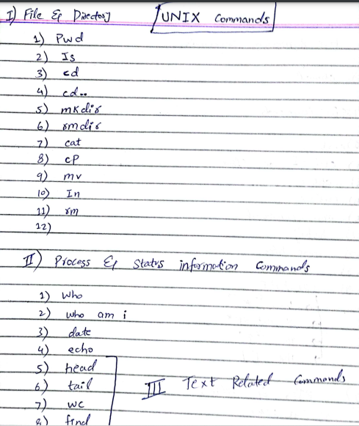

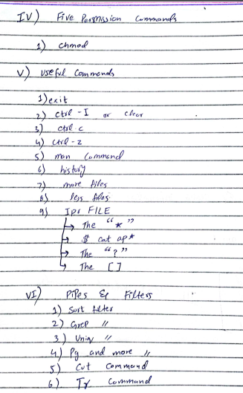

**Short explanation of commands**

|  |  |
| --- | --- |
| [cat](https://www.math.utah.edu/lab/unix/unix-commands.html#cat) | for creating and displaying short files |
| [chmod](https://www.math.utah.edu/lab/unix/unix-commands.html#chmod) | change permissions |
| [cd](https://www.math.utah.edu/lab/unix/unix-commands.html#cd) | change directory |
| [cp](https://www.math.utah.edu/lab/unix/unix-commands.html#cp) | for copying files |
| [date](https://www.math.utah.edu/lab/unix/unix-commands.html#date) | display date |
| [echo](https://www.math.utah.edu/lab/unix/unix-commands.html#echo) | echo argument |
| [ftp](https://www.math.utah.edu/lab/unix/unix-commands.html#ftp) | connect to a remote machine to download or upload files |
| [grep](https://www.math.utah.edu/lab/unix/unix-commands.html#grep) | search file |
| [head](https://www.math.utah.edu/lab/unix/unix-commands.html#head) | display first part of file |
| [ls](https://www.math.utah.edu/lab/unix/unix-commands.html#ls) | see what files you have |
| [lpr](https://www.math.utah.edu/lab/unix/unix-commands.html#lpr) | standard print command (see also [print](https://www.math.utah.edu/lab/unix/unix-commands.html#print)) |
| [more](https://www.math.utah.edu/lab/unix/unix-commands.html#more) | use to read files |
| [mkdir](https://www.math.utah.edu/lab/unix/unix-commands.html#mkdir) | create directory |
| [mv](https://www.math.utah.edu/lab/unix/unix-commands.html#mv) | for moving and renaming files |
| [ncftp](https://www.math.utah.edu/lab/unix/unix-commands.html#ncftp) | especially good for downloading files via anonymous [ftp](https://www.math.utah.edu/lab/unix/unix-commands.html#ftp). |
| [print](https://www.math.utah.edu/lab/unix/unix-commands.html#print) | custom print command (see also [lpr](https://www.math.utah.edu/lab/unix/unix-commands.html" \l "lpr)) |
| [pwd](https://www.math.utah.edu/lab/unix/unix-commands.html#pwd) | find out what directory you are in |
| [rm](https://www.math.utah.edu/lab/unix/unix-commands.html#rm) | remove a file |
| [rmdir](https://www.math.utah.edu/lab/unix/unix-commands.html#rmdir) | remove directory |
| [rsh](https://www.math.utah.edu/lab/unix/unix-commands.html#rsh) | remote shell |
| [setenv](https://www.math.utah.edu/lab/unix/unix-commands.html#setenv) | set an environment variable |
| [sort](https://www.math.utah.edu/lab/unix/unix-commands.html#sort) | sort file |
| [tail](https://www.math.utah.edu/lab/unix/unix-commands.html#tail) | display last part of file |
| [tar](https://www.math.utah.edu/lab/unix/unix-commands.html#tar) | create an archive, add or extract files |
| [telnet](https://www.math.utah.edu/lab/unix/unix-commands.html#telnet) | log in to another machine |
| [wc](https://www.math.utah.edu/lab/unix/unix-commands.html#wc) | count characters, words, lines |

**In detailed explanation**

1. **File and directory**

|  |  |
| --- | --- |
| **Command** | **Meaning** |
| PWD | The pwd command writes to standard output the full path name of your current directory (from the root directory). All directories are separated by a / (slash). The root directory is represented by the first /, and the last directory named is your current directory. |
| ls | The ls command is one of the most commonly used commands in daily Linux/UNIX operations. The command is used in listing contents inside a directory and is one of the few commands beginners learn from the onset. In this guide, we will discuss Common ls commands in Linux and other parameters as well that may be used alongside the command. |
| Cd | cd Unix Linux Command - cd - To change directory - change the current working directory to a specific Folder. |
| Cd.. (double dot) | The “cd..” command is used to navigate one directory level up which will lead us to directory /linux_files and the “cd../..” command is used to navigate two directories level which will lead us to directory /tutorials and continue. |
| mkdir | The mkdir command in Linux/Unix is a command-line utility that allows users to create new directories. mkdir stands for "make directory." With mkdir , you can also set permissions, create multiple directories at once, and much more. |
| Rmdir | The rmdir command removes the directory, specified by the Directory parameter, from the system. The directory must be empty before you can remove it, and you must have write permission in its parent directory. |
| Cat | The cat utility serves a dual purpose: concatenating and printing. With a single argument, it is often used to print a file to the user's terminal emulator (or historically to a computer terminal or teletype). |
| cP | The basic syntax for copying a file using the cp command is as follows:  cp source_file destination  This command creates a copy of the `source_file` at the specified `destination`. If the destination is a directory, the file is copied into that directory. |
| Mv | The mv command moves files and directories from one directory to another or renames a file or directory. If you move a file or directory to a new directory, it retains the base file name. When you move a file, all links to other files remain intact, except when you move it to a different file system. |
| Ln | The ln command is a standard Unix command utility used to create a hard link or a symbolic link (symlink) to an existing file or directory. |
| Rm | rm (short for remove) is a basic command on Unix and Unix-like operating systems used to remove objects such as computer files, directories and symbolic links from file systems and also special files such as device nodes, pipes and sockets, similar to the del command in MS-DOS, OS/2, and Microsoft Windows. |

**(II)Process & Status information**

|  |  |
| --- | --- |
| **Commands** | **Meaning** |
| **Who** | displays a list of users who are currently logged into the computer. |
| **Who am i** | prints the effective username of the current user when invoked. |
| **date** | date command*examples, syntax & help. Explains how show the*date*& time using a shell prompt on BSD, AIX, HP-UX &*Unix*-like systems* |
| **echo** | displaying lines of text or string which are passed as arguments on the command line. |

**(II)Text Related**

|  |  |
| --- | --- |
| **Commands** | **Meanings** |
| **head** | head command*, as the name implies, print the top N number of data of the given input. By default, it prints the first 10 lines of the ..* |
| **tail** | ail*is a*command*which prints the last few number of lines (10 lines by default) of a certain file, then terminates.* |
| **wc** | s a command line utility for printing newline, word and byte counts for files |
| **find** | find command*to search for files. To use the*find command*, at the*Unix*prompt, enter:*find*.* |

**(IV)** **Five Permission Commands**

|  |  |
| --- | --- |
| **Command** | **Meaning** |
| **Chmod** | To change file and directory permissions, use the command chmod (change mode). The owner of a file can change the permissions for user ( u ), group ( g ), or others ( o ) by adding ( + ) or subtracting ( - ) the read, write, and execute permissions. |

**(V) Useful Command**

|  |  |
| --- | --- |
| **Command** | **Meaning** |
| **Exit** | To exit the z/OS UNIX shell, after all foreground processes are complete, type exit . When the shell acknowledges the exit command, press Enter . You can also exit from the shell by pressing the Esc + D keys, in sequence, where Esc is a defined escape character that is displayed on the screen. |
| **Ctrl I or Clear** | The Unix command clear takes no arguments and is roughly analogous to the command cls on a number of other operating systems. In ISO 9995-7 specifies that the following symbol be used to indicate this function on a keyboard, which is included in Unicode as: ⎚ CLEAR SCREEN SYMBOL. |
| **Ctrl C** | Turned out the way Ctrl-c works is quite simple — it's just a shortcut key for sending the interrupt (terminate) signal SIGINT to the current process running in the foreground. Once the process gets that signal, it's terminating itself and returns the user to the shell prompt. |
| **Ctrl Z** | ctrl-z : keystroke: suspend the foreground process. bg : put the recently suspended process in the background. fg : put the recently suspended process in the foreground. & : run a program in the background to begin with. |
| **Man Command** | Linux Man Command. The "man" is a short term for manual page. In unix like operating systems such as linux, man is an interface to view the system's reference manual. A user can request to display a man page by simply typing man followed by a space and then argument. |
| **History Command** | The history command in Linux provides a chronological list of previously executed commands, along with corresponding command numbers. This feature allows users to recall, reuse, and modify commands without having to retype them |
| **More Files** | more filename --- shows the first part of a file, just as much as will fit on one screen. Just hit the space bar to see more or q to quit. You can use /pattern to search for a pattern. |
| **Less Files** | The less command in Unix is a pager used to display the contents of a text file on the screen one page at a time. It provides more flexible navigation and additional features compared to the basic cat command. Here are some key aspects of the less command: |
| **IPR File** | print. Use the -P option to specify the printer name if you want to use a printer other than your default printer. For example, if you want to print double-sided, use 'lpr -Pvalkyr-d', or if you're at CSLI, you may want to use 'lpr -Pcord115-d'. See 'help printers' for more information about printers and their locations. |
| **\*** | In a Unix/Linux cron job, the asterisk (*) symbol is used as a wildcard to specify all possible values for a given field in a cron expression. |
| **Cat ap** | You can use cat with redirection to append a file to another file. You do this by using the append redirection symbol, ``>>''. To append one file to the end of another, type cat, the file you want to append, then >>, then the file you want to append to, and press <Enter>. |
| **?** | Generally speaking, in Bash, a ? is a glob pattern that expands to an arbitrary character.  For example:  $ echo Hello1 > foo1  $ echo Hello2 > foo2  $ cat foo?  Hello1  Hello2  It is akin to a *, but a * expands to 0 or more characters, while a ? expands to exactly one (arbitrary) character.  In your special case though, the ? in the command was apparently a typo. |
| **[]** | Within the -exec stuff an argument of {} means "insert the file name here". So if the files were "foo" and "bar" it would execute "ls -a foo" then "ls -a bar". So all that meaning only means that because -exec is there. The -name * part of it might have been meant with * in quotes. |

**VI) Pipes and Filters**

|  |  |
| --- | --- |
| **Commands** | **Meaning** |
| **Sort filter** | The sort command sorts the contents of a file, in numeric or alphabetic order, and prints the results to standard output (usually the terminal screen). |
| **Grep filter** | grep command filters the content of a file which makes our search easy. It is a command-line utility to search plain-text data groups for lines that are the same as a regular expression. The name "grep" comes from the command, i.e., ed, which contains the same effect. |
| **Uniq Filter** | The uniq command deletes repeated lines in a file. The uniq command reads either standard input or a file specified by the InFile parameter. The command first compares adjacent lines and then removes the second and succeeding duplications of a line. Duplicated lines must be adjacent. |
| **Pg filter** | Use the pg command to read the files named in the File parameter and writes them to standard output one screen at a time |
| **More filter** | It is used to customize the displaying contents of file. It displays the text file contents on the terminal with paging controls. |
| **Cut command** | Linux cut command is useful for selecting a specific column of a file. It is used to cut a specific sections by byte position, character, and field and writes them to standard output. It cuts a line and extracts the text data. It is necessary to pass an argument with it; otherwise, it will throw an error message. |
| **Tr command** | tr is a command in Unix, Plan 9, Inferno, and Unix-like operating systems. It is an abbreviation of translate or transliterate, indicating its operation of replacing or removing specific characters in its input data set. |